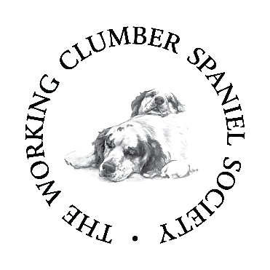
Information needed for a puppy and dogs for sale

- You must be a current member of the WCSS.
- The Dog and Bitch must be full heath tested
- All Heath test results must be showing on the Kennel Club website or evidence of the test results must be provied

Information to go on the website

- Copy of both the Dog and Bitches pedigree.
- A little write up about each dog with their full health test results listed, hips, elbows, PDP1, EIC and eye tests.
- Photograph of the dog and the bitch
- Location of litter but just the area eg Surrey
- Contact details including phone numbers and email addresses.

Email all the information to sarahwatterscarver@gmail.com

